1NC

First are the links:

Sequecing – Materiality comes first – a Marxist epistemology is not only valid, but challenges the radical right’s deployment of constructivism.
Dana L. Cloud, Steve Macek, and James Arnt Aune, ‘6 (Department of Communication Studies University of Texas, Austin Department of Speech Communication North Central College, Department of Communication Texas A&M “The Limbo of Ethical Simulacra”: A Reply to Ron Greene,” Philosophy and Rhetoric, Vol. 39, No. 1)-mikee
Greene and other … and human suffering.

b. Epistemological focus – Fixating on epistemological questions eliminates all productive potential – accepting truth claims, even if they are not perfect, is necessary for politically instrumental action
Cloud, Professor of Communication Studies at Texas, 2006
December, Communication and Critical/Cultural Studies
Of necessity, attention … structuralism and relativism.

c. Focus on discourse – more dangerous battleground, structural antagonism
Cloud, prof of Communication @ UTexas, 05 [Dana, Management Communication Quarterly, “Fighting Words: Labor and the Limits of Communication at Staley, 1993 to 1996”]
Like managers and … and other benefits (p. 189).

d. Their postmodern project insulates capitalism from criticism, blunts attempts to analyses market ideology, and allows the worst forms of capitalism to spread
Reconsidering Marx in Post-Marxist Times: A Requiem for Postmodernism?
Author(s): Peter McLaren and Ramin Farahmandpur
Source: Educational Researcher, Vol. 29, No. 3 (Apr., 2000), pp. 25-33
Published by: American Educational Research Association
Stable URL: http://www.jstor.org/staMi 11 n"il^^^M
Accessed: 11/09/2011 23:35
Despite its successes, … most troublesome determinations.

Its try or die for the negative—capitalism makes multiple scenarios for extinction an inevitability.
Theory & Praxis 2009
http://one-dimensional.blogspot.com/
In a little …to smash it.

The impact—capitalism pathologically prioritizes short-term profit over long term viability of the system—this form of rationalistic logic guarantees the inevitable deployment of every scenario for global destruction including nuclear war, ecological damage, space militarization, and many other scenarios—extinction is inevitable in their framework—alternative is the only hope because humanity survives on a thin margin generated by the dissidence against capitalism in imperial states—its try or die
Marko 2003—5/14, https://www2.indymedia.org.uk/en/2003/05/68173.html
Bertrand Russell throughout … of its time.

Alt: Vote negative as an act of solidarity.

Struggles matter – Solidarity transcends nationality and makes resistance to institutions possible. It’s about embracing actions, not revealing.
Cloud, Professor of Communication Studies @ Texas, ‘6 (Dana, Communication and Critical/Cultural Studies Vol. 3, No. 4, December, pp. 329􏰜354, “The Matrix and Critical Theory’s Desertion of the Real.”)-mikee
Aimed at producing … anti-sweatshop movement.119

1NR

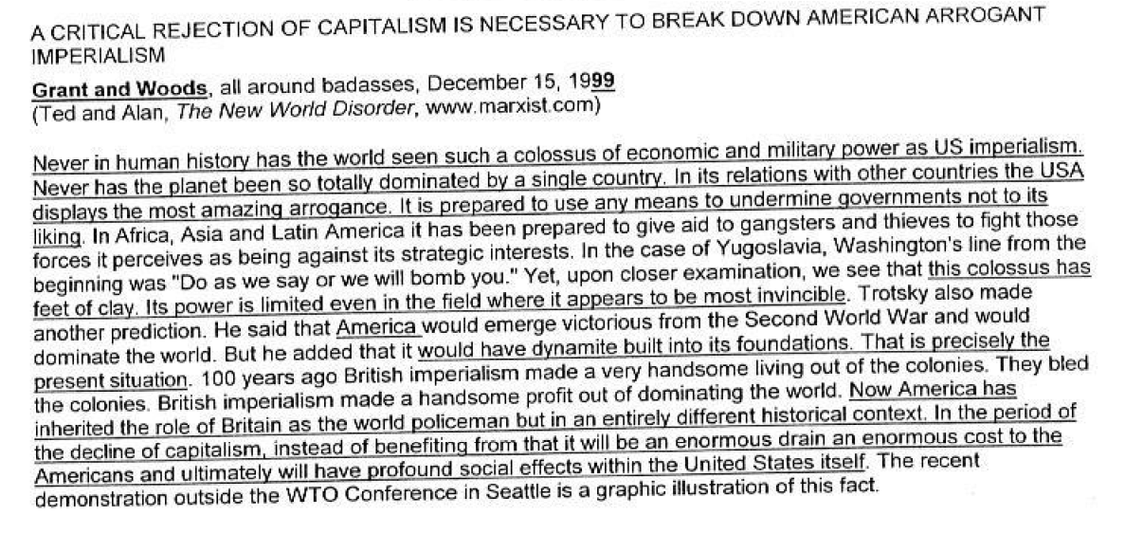

And, Iraq proves that capitalism still needs physical forces – only voting negative offers an emancipatory politics based on solidarity with countless movements challenging capitalism.
Dana L. Cloud, Steve Macek, and James Arnt Aune, ‘6 (Department of Communication Studies University of Texas, Austin Department of Speech Communication North Central College, Department of Communication Texas A&M “The Limbo of Ethical Simulacra”: A Reply to Ron Greene,” Philosophy and Rhetoric, Vol. 39, No. 1)-mikee
On this point, … stage of history.

They posit stories of change as more important than Marxist change – cultural changes distract us from proper material ways to deal with capitalist exploitation of labor
Stephen Tumino, English—Pitt, 2002
“Contesting the Empire-al Imaginary: The Truth of Democracy as Class,” http://www.redcritique.org/MayJune02/contestingtheempirealimaginary.htm
Against the totally … now in the US.

Recognition of capitalism is not enough – their understanding of capitalism through an epistemological lens makes deciding between competing representations impossible, ignoring the ontological effect unequal distributions of wealth have on power relationships
Kapoor, 2008 (Ilan, Associate Professor at the Faculty of Environmental Studies, York University, “The Postcolonial Politics of Development,” p. 15-16)
The problem is that … types of situations.

